**Python and Bash Assignment**

1. **Grade Checker**

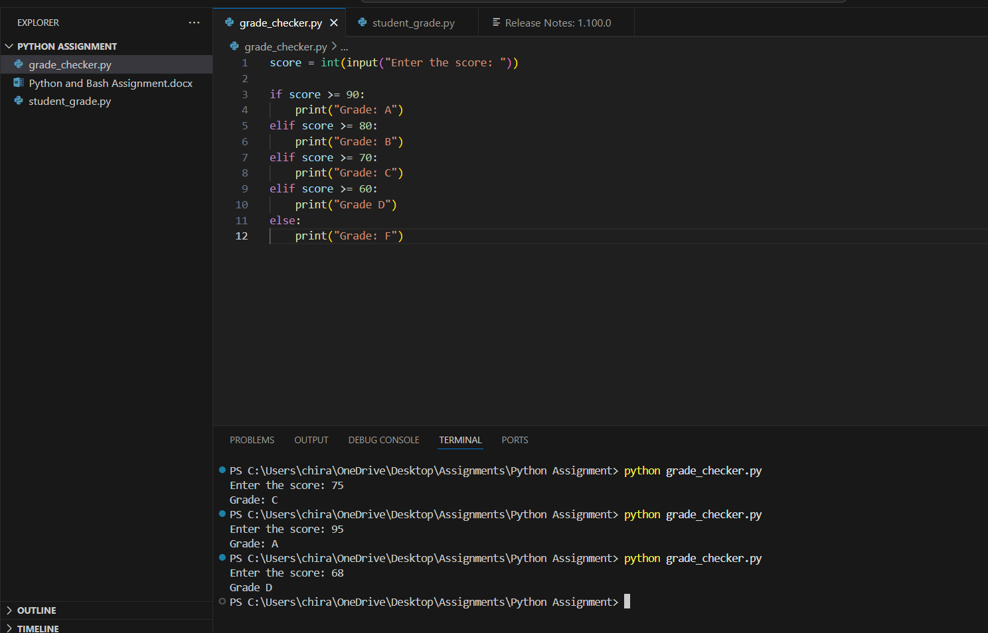

**Explanation:**

* Input() – prompt to enter value.
* Uses if-elif-else statement.
* Categorizes the score into a grade based on standard.

**2 Student Grades**

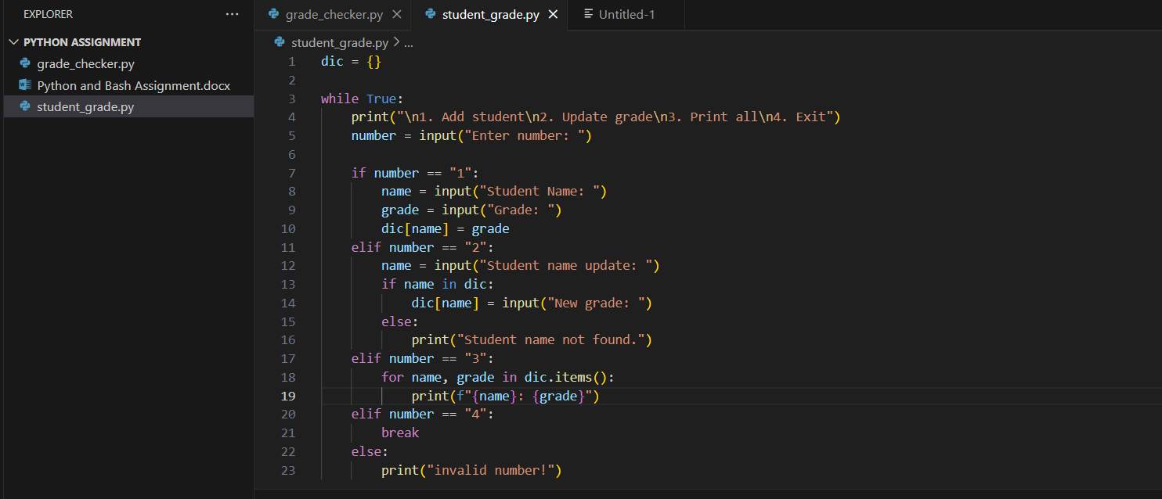

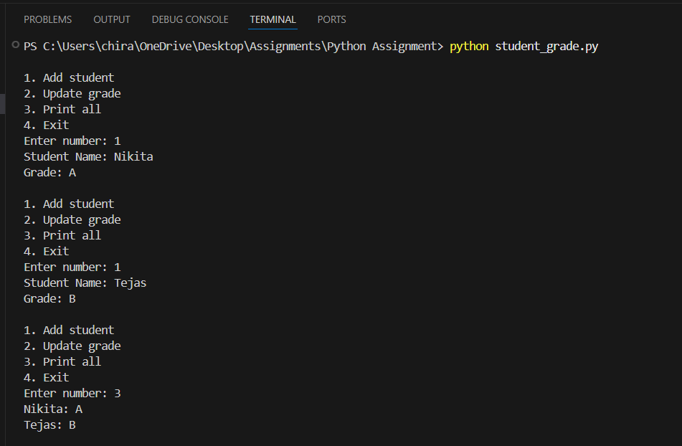

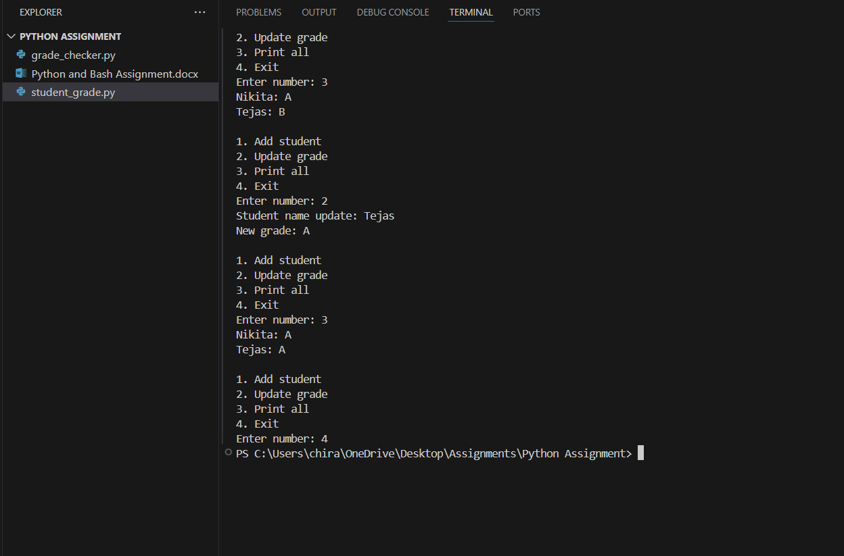

**Explanation:**

* A dictionary is used to store student data.
* while True: -Starts an **infinite loop** that will continue until **break** is used.
* print – to display the output.

**3.Write to a File**

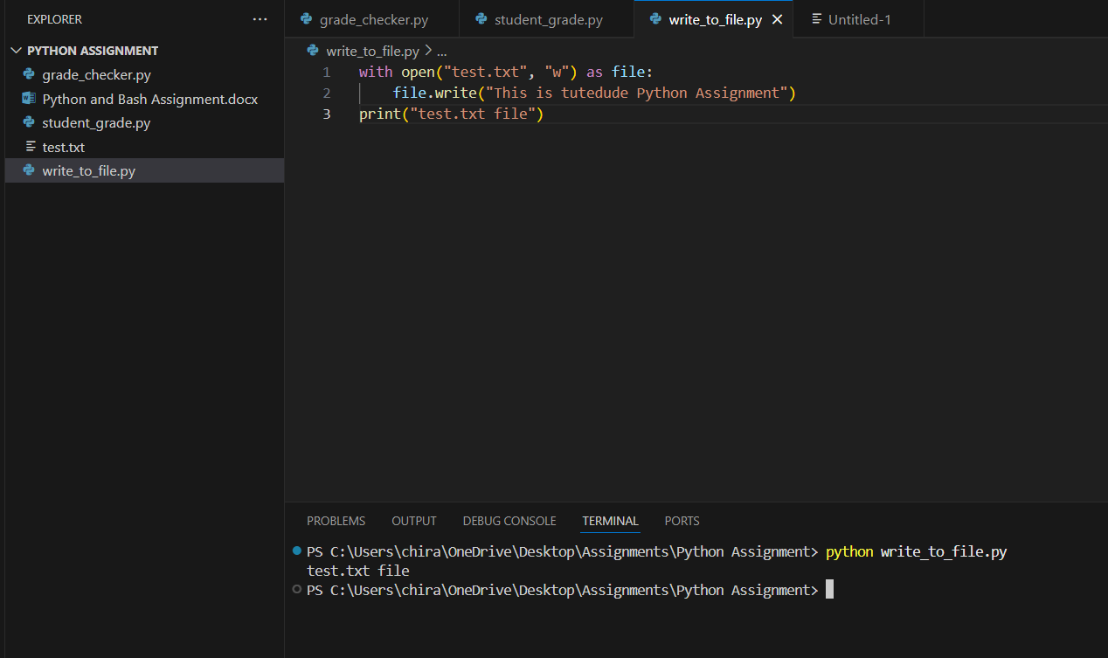

**Explanation:**

* open() – open or create a file.
* “w” – write mode.
* with – automatically close and open the files.
* \n – new line character.

**4. Read from a File**

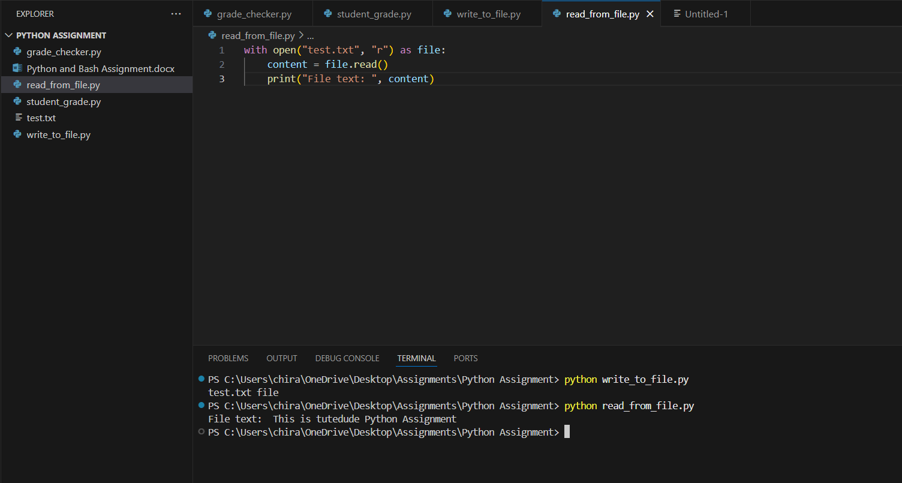

**Explanation:**

* “r” – read mode.
* test.txt – a text file.